**Computing Fundamentals & Programming**

**Assignment 8**

**Question 1**

Write a C++ program that reads an integer number from the user as an input. It should then separate the digits and store each in an array. The user can enter up to 8 digits. The program prints a new number on the using the following rule:

Numbers with the odd number of digits is rotated about the middle number and even numbers are rotated about the 2 middle digits. In order to understand this question, see the example below. The numbers having the same color are swapped to produce the rotated new number:

Example 1: User Entered 12345 then program should print 54321

Example 2: User Entered 123456 then program should print 653421

Code:

**int** countDigits(**int** num) { *//counts the digit of the number given by user*

**int** count = 0;

**while** (num > 0) { *//loop will not stop until num will be smaller than ZERO*

num = num / 10;

count++; *//increment COUNT by 1 on each iteration*

}

**return** count; *//returns count to hte function*

}

**void** swapEven(**int** num, **int** arr[DIM]) { *//this function will rotate digits in even number*

**int** count = countDigits(num); *//tells the number of digit*

**int** mid = count / 2; *//divides count by 2 in order to get its half value*

mid = mid - 1; *//subtract -1 from "mid" in order to align it with indexing of array*

**for** (**int** i = 0; i < count; i++) { *// array control statement*

**if** (i < mid) { *//this condition will be true for the indexes smaller than the mid index of the array*

cout << arr[i]; *//prints the value on the index*

}

**if** (i == mid) { *//this condition will be true for the mid index of the array*

cout << arr[i + 1]; *//prints the next value after the index value*

}

**if** (i == mid + 1) { *//this condition will be true for the index after the mid index of the array*

cout << arr[mid]; *//prints the value on the mid index*

}

**if** (i > mid + 1) { *//this condition will be true for the indexes after (mid + 1) index of the array*

cout << arr[i]; *//prints the value on the index*

}

}

cout << endl; *// Jumps on the new line*

}

**void** swap(**int** arr[DIM]) { *// this function will rotates digit of the number given by the user*

**int** digit, num, count, pseudo; *// declares variables needed*

cout << **"Rule: Numbers with the odd number of digits is rotated about the middle number and "**;

cout <<**"even numbers are rotated about the 2 middle digits."**<< endl;

cout << **"ENTER ANY NUMBER TO ROTATE ITS DIGITS ACCORDING TO THE ABOVE RULE "** << endl;

cout << **"Note: Only 8 digits are allowed in the number:"**;

**do** {

cin >> num; *//read a number from the user*

pseudo = num; *//save it to another number to preserve it*

count = countDigits(num); *//counts the digits in the number*

} **while** (count > 8 && cout << **"Limit exceeded, Type the number within limit: "** << endl); *//if the digits in the no.*

cout << **"Rotated Number is: "**; *//will be more than 8, it will again asks the user to type the number in the limit*

**for** (**int** i = 0; i < count; i++) { *// array control statement*

digit = num % 10; *//This line combine with below line separates the digits from the number*

num = num / 10;

arr[i] = digit; *//This line will save the digits in the array in reverse order*

**if** (count % 2 != 0) { *//this condition will works if number of digits is odd*

cout << arr[i]; *//prints digits rotated about the middle digit*

}

}

**if** (count % 2 != 0) { *//this condition will works if number of digits is odd*

cout << endl; *//jump to new line*

}

**if** (count % 2 == 0) { *//this condition will works if number of digits is even*

swapEven(pseudo, arr); *//prints digits rotated about the 2 middle digit*

}

}

Output:

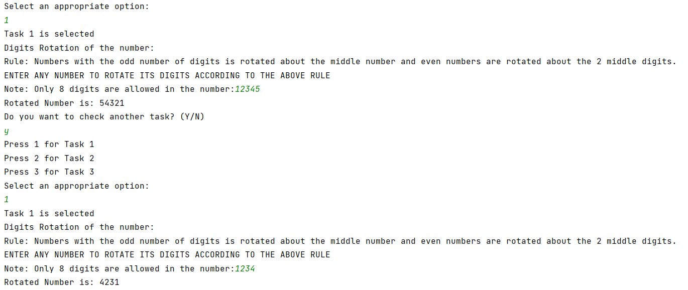

**Question 2**

Write a program to calculate pow(x,n), x, and n are two integers. write a function to compute x^n.

Code:

**int** pow(**int** x, **int** n) { *//this function will calculate power*

**int** result = 1; *//sets result to 1*

**do** {

result = result * x; *//multiply result with base(x) and save it in result*

n--; *//decrement n until it reaches zero*

} **while** (n != 0); *//stops the loop when n will be zero*

**return** result; *//passes value to the function*

}

Output:

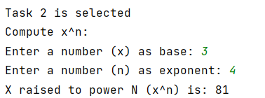

**Question 3**

Write a C++ program that will read two numbers from the user and perform the following operations i.e. add, subtract, multiply, divide and remainder (sort of calculator) by using pointers. There should be one function against one functionality. e.g. int sum(-------)

Code:

**int** addition(**int** num1, **int** num2) { *//this function will perform addition on two numbers provided by the user*

**int** add;

add = num1 + num2;

**return** add;

}

**int** multiplication(**int** num1, **int** num2) { *//this function will perform multiplication on two numbers provided by the user*

**int** multi;

multi = num1 * num2;

**return** multi;

}

**int** division(**int** num1, **int** num2) { *//this function will perform division on two numbers provided by the user*

**int** div;

div = num1 / num2;

**return** div;

}

**int** subtraction(**int** num1, **int** num2) { *//this function will perform subtraction on two numbers provided by the user*

**int** sub;

sub = num1 - num2;

**return** sub;

}

**int** remainder(**int** num1, **int** num2) { *//this function will find remainder of two numbers provided by the user*

**int** rem;

rem = num1 % num2;

**return** rem;

}

**void** pntcalculate() { *//calculator by pointer*

string again; *//declares an string*

**int** *pnt; *//declares an pointer*

**int** result, menu, num1, num2; *//declares variables needed*

skip:

pnt = &num1; *//directs pointer to num1*

cout << **"Enter a number: "**;

cin >> *pnt;*//input value at the location where pointer is pointing*

pnt = &num2; *//directs pointer to num2*

cout << **"Enter a number: "**;

cin >> *pnt;*//input value at the location where pointer is pointing*

pnt = &result; *//directs pointer to result*

cout << **"_______________________________________________________"** << endl;

cout << **"\t\t\t\tArithmetic Calculator"** << endl;

cout << **"_______________________________________________________"** << endl;

cout << **"Press 1 for addition"** << endl;

cout << **"Press 2 for subtraction"** << endl;

cout << **"Press 3 for multiplication"** << endl;

cout << **"Press 4 for division"** << endl;

cout << **"Press 5 for checking remainder (Decimal values are not supported)"** << endl;

cout << **"_______________________________________________________"** << endl;

cout << **"Tell me which arithmetic function you want to perform? "** << endl;

cin >> menu; *//inputs the MENU option from the user*

cout << **"_______________________________________________________"** << endl;

**if** (menu <= 5) { *//if the option selected is smaller than or equal to 5 then following statements will execute*

**switch** (menu) { *//switch case variable*

**case** 1:

*pnt = addition(num1, num2); *//saves the value returned by function to the location where pointer is pointing*

cout << **"Your desired calculation is: "** << endl;

cout << num1 << **"+"** << num2 << **"="** << result << endl; *//prints the result saved by the pointer*

**break**;

**case** 2:

*pnt = subtraction(num1, num2); *//saves the value returned by function to the location where pointer is pointing*

cout << **"Your desired calculation is: "** << endl;

cout << num1 << **"-"** << num2 << **"="** << result << endl; *//prints the result saved by the pointer*

**break**;

**case** 3:

*pnt = multiplication(num1, num2); *//saves the value returned by function to the location where pointer is pointing*

cout << **"Your desired calculation is: "** << endl;

cout << num1 << **"x"** << num2 << **"="** << result << endl; *//prints the result saved by the pointer*

**break**;

**case** 4:

*pnt = division(num1, num2); *//saves the value returned by function to the location where pointer is pointing*

cout << **"Your desired calculation is: "** << endl;

cout << num1 << **"÷"** << num2 << **"="** << result << endl; *//prints the result saved by the pointer*

**break**;

**case** 5:

*pnt = remainder(num1, num2); *//saves the value returned by function to the location where pointer is pointing*

cout << **"Your desired calculation is: "** << endl;

cout << num1 << **" mod "** << num2 << **" = "** << result << endl; *//prints the result saved by the pointer*

**break**;

}

} **else** cout << **"Invalid Input"** << endl;

cout << **"Do you want to use calculator again? (Y/N)"** << endl; *//asks the user whether he want to use again calculator*

cin >> again;

**if** (again == **"N" or** again == **"n" or** again == **"no" or** again == **"NO" or** again == **"No" or** again == **"nO"**) {

cout << **"Calculator Closed"** << endl;

} **else goto** skip;

}

Output:

